Standard operating procedure for civil defence response to disaster – cyclone

- The mandate

Under the 2010 amendment to the Civil Defence Act, 1968, “civil defence” includes “… any measure taken for the purpose of disaster management, before, during, at, or after any disaster …” Under section 2 (d) of the Disaster Management Act, 2005, “”“disaster” means a catastrophe, mishap, calamity or grave occurrence in any area, arising from natural or man made causes, or by accident or negligence which results in substantial loss of life or human suffering or damage to, and destruction of, property, or damage to, or degradation of, environment, and is of such a nature or magnitude as to be beyond the coping capacity of the community of the affected area.”

Under section 2 (e) of the Disaster Management Act, 2005, ““disaster management” means a continuous and integrated process of planning, organising, coordinating and implementing measures which are necessary or expedient for—
- prevention of danger or threat of any disaster;

- mitigation or reduction of risk of any disaster or its severity or consequences;

- capacity-building;

- preparedness to deal with any disaster;

- prompt response to any threatening disaster situation or disaster;

- assessing the severity or magnitude of effects of any disaster;

- evacuation, rescue and relief;

- rehabilitation and reconstruction.”

In the case of cyclones, Civil Defence Organisation, West Bengal and its different wings are expected to contribute towards the state government efforts regarding sub paras (ii) – (v) and (vii) of the previous paragraph.

- Cyclone

According to Glossary of Meteorology, American Meteorological Society, a “cyclone” is a large scale air mass that rotates around a strong centre of low atmospheric pressure. A tropical cyclone is a storm system characterized by a low-pressure centre and numerous thunderstorms that produce strong winds and flooding rain. A tropical cyclone feeds on heat released when moist air rises, resulting in condensation of water vapour contained in the moist air. They are fuelled by a different heat mechanism than other cyclonic windstorms. The wind rotation is counterclockwise in the Northern Hemisphere. While tropical cyclones can produce extremely powerful winds and torrential rain, they are also able to produce high waves and a damaging storm surge. Their winds increase the wave size, and in so doing they draw more heat and moisture into their system, thereby increasing their strength. They develop over large bodies of warm water and hence lose their strength if they move over land. Coastal regions can receive significant damage from a tropical cyclone, while inland regions are relatively safe from strong winds. Heavy rains, however, can produce significant flooding inland. Storm surges are rises in sea level caused by the reduced pressure of the core that in effect "sucks" the water upward and from winds that in effect "pile" the water up. Storm surges can produce extensive coastal flooding up to 40 kilometres from the coastline.

Indian Meteorological Department (IMD) has characterised different cyclonic activity as below:

Category | Maximum sustained surface wind speed
Depression | 31 – 49 kmph
Deep depression | 50 – 61 kmph
Cyclonic storm | 62 – 88 kmph
Severe cyclonic storm | 89 – 117 kmph
Very severe cyclonic storm | 118 – 166 kmph
Extremely severe cyclonic storm | 167 – 221 kmph
Super cyclonic storm | = or > 222 kmph

IMD issues cyclone warnings in four stages. The first stage warning known as "PRE CYCLONE WATCH" issued 72 hours in advance contains early warning about the development of a cyclonic disturbance in the north Indian Ocean, its likely intensification into a tropical cyclone and the coastal belt likely to experience adverse weather. The second stage warning known as "CYCLONE ALERT" is issued at least 48 hrs. in advance of the expected commencement of adverse weather over the coastal areas. It contains information on the location and intensity of the storm, likely direction of its movement, intensification, coastal districts likely to experience adverse weather and advice to fishermen, general public, media and disaster managers. The third stage warning known as "CYCLONE WARNING" is issued at least 24 hours in advance of the expected commencement of adverse weather over the coastal areas. Landfall point is forecast at this stage. These warnings are issued at 3 hourly interval giving the latest position of cyclone and its intensity, likely point and time of landfall, associated heavy rainfall, strong wind and storm surge alongwith their impact and advice to general public, media, fishermen and disaster managers. The fourth stage of warning known as "POST LANDFALL OUTLOOK" is issued at least 12 hours in advance of expected time of landfall. It gives likely direction of movement of the cyclone after its landfall and adverse weather likely to be experienced in the interior areas.

Different colour codes as mentioned below are being used for the different stages of the cyclone warning bulletins as desired by the National Disaster Management.

Stage of warning | Colour code
Cyclone alert | Yellow
Cyclone warning | Orange
Post landfall outlook | Red

- Cyclone prone and vulnerable areas of West Bengal

While almost all districts of West Bengal may be affected by cyclone, the risk and vulnerability are greater, the closer the areas are to the coast. Following are the vulnerable areas of West Bengal. Some of them have been affected by recent major cyclones.

Vulnerable district | Affected by
 | Fani  2019 | Aila  2009
E Medinipur | _/ | _/
W Medinipur | _/
Jhargram | _/
Howrah |  | _/
Hoogly |  | _/
Burdwan |  | _/
South 24 Parganas | _/ | _/
North 24 Parganas
Nadia
Darjeeling |  | _/ (Due to heavy rains and flooding)
Kolkata | _/ | _/

- Action before a cyclone

Cyclones cannot be prevented. However, the better the awareness of and planning for it, the less is the loss of lives and property and disruption of normal life and faster is the recovery. Enhancing disaster preparedness for effective response is one of the specific priorities for action as laid down in the Sendai Framework for Disaster Risk Reduction (2015 – 2030). Towards this end, the following actions are indicated for Civil Defence:

- Thorough training of the staff and the volunteers of the cyclone prone vulnerable areas in cyclone awareness and preparedness in cyclone disaster mitigation.
- Preparing and maintaining a digitalised list of active volunteers and their contact details. Sufficient volunteers should be trained in handling of modern rescue equipment.
- Holding of cyclone awareness camps in the cyclone prone and vulnerable areas and educating the general public about action to be taken in the event of a cyclone alert or cyclone warning. Use of cartoons and drawings will help better absorption and engagement by the audience. Evacuation games may be organised in schools.
- Distribution of “My Disaster Evacuation Card” and chart to the public about the nearest cyclone/ storm centre and best/ alternate route of reaching the same.
- Having the rescue centre and the Civil Defence Rescue Vehicles in operational readiness at all times.
- Monthly inspection of rescue equipment and their prompt repair and replacement, if needed.
- Preparation of list of nodal officers of other agencies like Disaster Management, Police, Medical service, district authorities, fishermen association, ambulance services, etc..
- Designation of an assembly point and an alternate assembly point of the nodal officers in the event of a disaster.
- Mock drills for cyclones should be arranged in coordination with all the concerned agencies in the cyclone prone and vulnerable areas at least once a year. The observers’ check list is as per Annexure 1.
- Reinforcements of officers, staff, Agragamis, boats, OBMs and equipment are likely. Their accommodation, catering and operations need to be planned for.
- The normal communication systems like cell phones may come under severe stress. Alternative communication system like wireless, satellite phones, etc. should be kept in readiness and in charged condition. Power sources may be disrupted. Inverters, generators an power banks should be catered for. In case the disaster recovery is prolonged, a “battle rhythm”, i.e., fixed times for meeting of the key rescue officials at a designated point should be fixed in advance. If possible, during mock exercise, the electricity and telephone network may be switched off or avoided so that the participants drill on how to operate without the regular phones.

- Action during a cyclone (starting with Code Orange, Cyclone warning)

- Move the men, material and equipment to be in readiness in areas of need. The available resources in the vulnerable districts and the desirable resources at vulnerable points are given in Annexure 2. The shortfall should be moved from HQ and other districts as soon as the warning is received.
- Immediately establish a communication system for the rescue workers and with the district and disaster management authorities, Police, etc.
- Track the movement of the cyclone through “windy” or other apps and monitor the electronic media and IMD bulletins.
- Help the authorities in evacuation of vulnerable population.
- Sagar sathis should keep a sharp watch along the coast to see that unaware persons do not go to danger areas and the sea.
- Make extensive use of loudhailers.

- Action at the cyclone site

- During high wind speeds of the cyclone, movement of Civil Defence teams is not possible or desirable. The activity should revolve around monitoring, warning, siren and loud hailer.
- Action should be taken to see that the communication system is operational and continuous.
- The nodal officers on the ground of each of the agency involved should be in constant touch with each other and update each other, the respective control rooms and their higher authorities for updating on the situation.

- Action after cyclone

- The immediate aftermath of the cyclone calls for maximum effort and presence of mind of the Civil Defence deployment. The aim should be to restore the transport and communication network as quickly as possible so that rescue and relief efforts can reach the affected people and places.
- The roads will be clogged with broken trees and debris. These should be cleared expeditiously.
- Broken buildings should be inspected to rescue trapped people and animals and these should be transported to the relief camp as soon as possible.
- The injured persons should be triaged as per the following protocol:
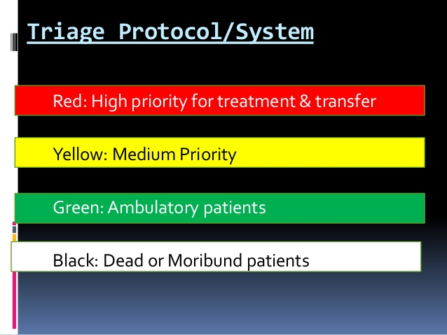
Triage should be done only by a trained Medical Officer or paramedic of the Casualty service or Health department/ medical unit.

- For each Civil Defence team operating at any site, the chain of command should be clearly defined, preferably by the SOI/ Sr SOI.
- The Civil Defence staff operating at the site are not authorised to speak to the media. Any media query should be referred to the authority designated for media briefing by the district authorities or higher formations.
- Normally, Civil Defence is not expected to be part of rehabilitation efforts. However, if the occasion arises and, under permission of HQ, the Civil Defence teams may be engaged in the same as a supporting hand.
- The stand down will be arranged by the district authorities. However, Civil Defence HQ retains primacy over stand down and release of Civil Defence teams and their redeployment elsewhere.

[Some pictures of Cyclone ‘Fani.’ May 2019]
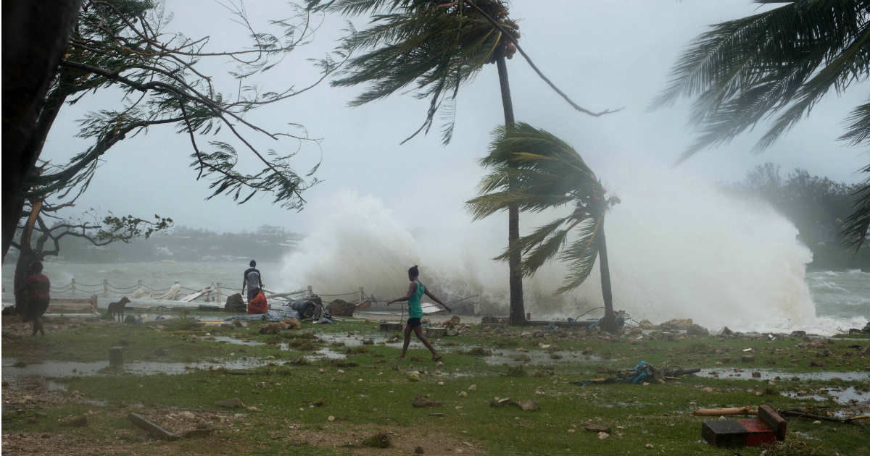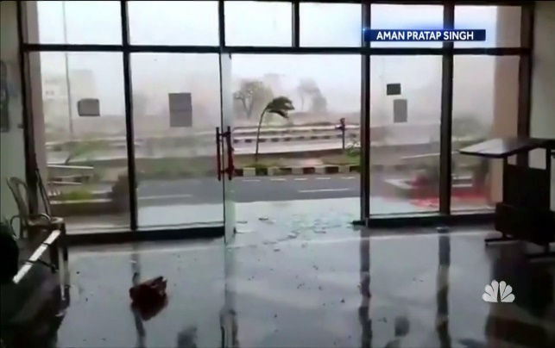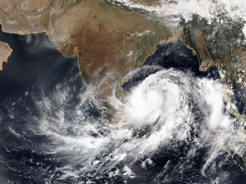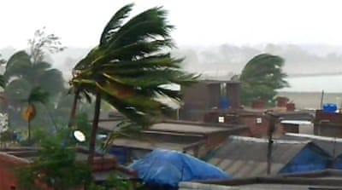

- Authorities and contact persons as on 2.6.2019:

Sl | Organisation | Designation | Name (Smt/ Shri/ Dr) | Phone no.  Email id
1 | Disaster Mangement | Principal Secretary | D. Nariala | 033-22143674
 |  | EOCC |  | 1070  033-22143526  033-22145664  033-22535185
 |  | Jt Secretary | S.S. Bhattacharya | 033-22501004
 |  | Director |  | 033-22275820
2 | Civil Defence | Director | B.B. Dash | 033-22252179
 |  | Nodal Officer | P.J. Ray
 |  | CR |  | 033-22374033  033-22363594
3 | IMD, Kolkata |  |  | 033-24793167  033-24790596
4 | State Disaster Response Force | ADG (Ops) |  | 033-22145486  033-22144031  033-22145009
 |  | WBP CR |  | 033-22144031  033-22145486
5 | Kolkata Police | DCP, Combat | N. Singh | 033-24794025
 | Kolkata Municipal Corporation | Control Room |  | 033-22861212  033-22861313  033-22861414
6 | NDRF | 2nd Bn, Haringhata |  | 033-25875032
7 | Health & Family Welfare Department |  |  | 033-23576000  033-23330100
8 | Fisheries Department | Secretary |  | 033-23570077
9 | Indian Army | Col. GS Bengal Area |  | 033-22232953  033-22133351
10 | Indian Air Force | Adv HQ EAC | 033-22482152
11 | Fire Services | DG |  | 033-22527172
 |  | Control Room |  | 033-22521165
12 | All India Radio, Kolkata |  |  | 033-22485336
13 | BSNL | AGM (EB – II) |  | 033-22426000
14 | Coast Guard | Dy Commandant | Ravi Kumar | 03224-267755

This list should be updated once in three months and, invariably, immediately upon intimation of an impending cyclone.

- Do’s and Don’ts

Following are the Do’s and Don’ts for members of the public in the face of a cyclone. The list is not exhaustive.
Before the Cyclone season
- Check the house; secure loose tiles and carry out repairs of doors and windows.
- Remove dead branches or dying trees close to the house; anchor removable objects such as lumber piles, loose tin sheets, loose bricks, garbage cans, sign-boards etc. which can fly in strong winds.
- Keep some wooden boards ready so that glass windows can be boarded if needed
- Keep a hurricane lantern filled with kerosene, battery operated torches and enough dry cells.
- Demolish condemned buildings.
- Keep some extra batteries for transistors.
- Keep some dry non-perishable food always ready for use in emergency.

When the cyclone has crossed the coast

When the Cyclone starts
- Listen to the radio (All India Radio stations give weather warnings).
- Keep monitoring the warnings. This will help you prepare for a cyclone emergency.
- Pass the information to others.
- Ignore rumours and do not spread them; this will help to avoid panic situations.
- Believe in the official information
- When a cyclone alert is on for your area continue normal working but stay alert to the radio warnings.
- Stay alert for the next 24 hours as a cyclone alert means that the danger is within 24 hours.
- When your area is under cyclone warning get away from low-lying beaches or other low-lying areas close to the coast.
- Leave early before your way to high ground or shelter gets flooded.
- Do not delay and run the risk of being marooned.
- If your house is securely built on high ground take shelter in the safe part of the house. However, if asked to evacuate do not hesitate to leave the place.
- Board up glass windows or put storm shutters in place.
- Provide strong suitable support for outside doors.
- If you do not have wooden boards handy, paste paper strips on glasses to prevent splinters. However, this may not avoid breaking windows.
- Get extra food, which can be eaten without cooking. Store extra drinking water in suitably covered vessels.
- If you have to evacuate the house move your valuable articles to upper floors to minimize flood damage.
- Ensure that your hurricane lantern, torches or other emergency lights are in working condition and keep them handy.
- Small and loose things, which can fly in strong winds, should be stored safely in a room.
- Be sure that a window and door can be opened only on the side opposite to the one facing the wind.
- Make provision for children and adults requiring special diet.
- If the centre of the cyclone is passing directly over your house there will be a lull in the wind and rain lasting for half an hour or so. During this time do not go out; because immediately after that, very strong winds will blow from the opposite direction.
- Switch off the electrical mains in your house.
- Remain calm.

When Evacuation is instructed

- Pack essentials for yourself and your family to last a few days. These should include medicines, special food for babies and children or elders.
- Head for the proper shelter or evacuation points indicated for your area.
- Do not worry about your property
- At the shelter follow instructions of the person in charge.
- Remain in the shelter until you are informed to leave
- Post-cyclone measures
- You should remain in the shelter until informed that you can return to your home.
- You must get inoculated against diseases immediately.
- Strictly avoid any loose and dangling wires from lamp posts.
- If you have to drive, do drive carefully.
- Clear debris from your premises immediately.
- Report the correct losses to appropriate authorities.

Annexure 1

Mock Drill on Cyclone

Observer’s report

District _________________ Block ________________ Police Station: ___________

Mock drill site ___________________

Date ____________________ Time from _____________ to ________________

Debriefing at _____________________ Debrief chaired by ____________________

Minutes: Memo. no. ___________________ dt. ________________ circulated on ___________________

- Observer:

Name __________________________________ Orgn. ___________________________

Designation _____________ Email _______________ Ph/ Mobile no. _______________

- Dissemination of information

- Central Communication Centre: Exists/ Does not exist
- Information dissemination started at: ___________ hrs.
- Nodal officers that could be contacted: _________ nos.
- Nodal officers that could not be contacted: ______ nos.
- Whatsapp group: Exists/ Does not exist. Used/ Not used
- SMS group: Exists/ Does not exist. Used/ Not used

- Was the electricity supply suspended for the exercise? Yes/ No

- Were the telephone networks suspended for the exercise? Yes/ No
If yes, how did the nodal officers communicate with each other/ their headquarters?
__________________________________________________________________________________________________________________________________________

- (i) Assembly point: Earmarked/ Not earmarked
(ii) Alternate assembly point: Earmarked/ Not earmarked

- Response time of different stake holders:

Team | Contacted at | Targeted reaching time | Reached at/ Did not reach/ Not applicable
CD QRT team
CD Medical team
CD Water Wing
CD Divers
DMG team
Fire fighting team
District Medical team/ Casualty service
Police
Municipal team
NDRF
SDRF

- SOP prepared and available with which authorities? __________________________________________________________________________________________________________________________________________

- SOP not prepared by which authorities?

__________________________________________________________________________________________________________________________________________

- Availability/ functionality of the following equipment in the CDRV:

Sl | Equipment | Prescribed quantity  Big/ Mini | Available quantity | Functional quantity
1 | Fluorescent Orange Reflective ID Jacket | 25/10
2 | Heavy duty working gloves | 05
3 | Life Jacket with reflective panels | 05
4 | FRP Industrial safety Helmet with chin strap (without visor) | 10
5 | FRP Industrial safety Helmet with chin strap with Visor | 02
6 | FRP Industrial safety Helmet with chin strap with LED Light | 02
7 | Disposable Mask | 20/10
8 | Circular Saw with 1 diamond blade and 1 abrasive blade | 01
9 | Bullet Chain Saw | 01
10 | Hand held rechargeable Search Light with 2 charger | 02
11 | Telescopic 40 ft. Aluminium ladder in double extension | 01
12 | Semi-Static Kernmantle Rope (100 mtr. roll) 11 m.m.dia | 01
13 | Seat Harness Adjustable | 01
14 | Screw Carabineer | 04
15 | Quick draw with 2 Carabineers | 04
16 | Stop Lock descending | 01
17 | Tandem pulley | 02
18 | Fixed Pulley | 02
19 | Foot Tape Sling 150 cm | 02
20 | Ascender new manual left and right | 01
21 | Sledge Hammer | 01
22 | Fire-Axe | 02/01
23 | Spade 5 ft. | 02/01
24 | Shovel 10” D-handle | 04/02
25 | Crowbar 5 ft. | 04/02
26 | Fibre Rescue Stretcher with Belt and Canvas Stretcher | 03/01
27 | Blanket (Woollen) | 02
28 | First Aid Box | 02/01
29 | Mega Phone Shoulder Sling Type | 02/01
30 | Giri-Giri | 01
31 | Search cam | 01
32 | Fire Entry Suit | 01
33 | Tri pod With Winch | 01
34 | Bullet Chain Saw | 01
35 | Circular saw | 01
36 | Concrete cutting saw | 01

- Availability/ functionality of other resources:

Sl | Resource | Prescribed | Availability | Functionality
1 | Boats
2 | Loudhailers
3 | Torchlight
4 | Generator set
5 | Fall braking net
6 | Ambulance
7 | First aid equipment
8 | Candles
9 | SCUBA sets
10 | Tents

- Availability of the following with the first aid team:

Sl | Item | Available/ Not available  A/ NA | Sl | Item | Available/ Not available  A/ NA
1 | Stethoscope |  | 18 | BP Apparatus Digital
2 | Thermometer Digital |  | 19 | Torch
3 | Bag Valve Mask Adult |  | 20 | Glucometer
4 | Bag Valve Mask Child |  | 21 | Flexible Collar for Cervical & Lumbar injury
5 | Bag Valve Mask Infant |  | 22 | Scissors
6 | Tray |  | 23 | Apron
7 | Surgical Gloves |  | 24 | Face Mask
8 | Oxygen Cylinder with Apparatus |  | 25 | Stretcher
9 | Nebuliser |  | 26 | Pulse Oxymeter
10 | Sterile Gauze pads of different sizes |  | 27 | Adhesive Tape
11 | Adhesive Bandages in different sizes |  | 28 | Antiseptic Wipes/ Alcohol Wipes
12 | Elastic Bandages |  | 29 | Soap
13 | Splint |  | 30 | Antibiotic Ointment
14 | Antiseptic Solution |  | 31 | Hydrocortisone Cream
15 | Acetaminophen/ Ibuprofen |  | 32 | Tweezers
16 | Calamine Lotion |  | 33 | Safety Pins
17 | Mouthpiece for giving CPR |  | 34 | Blanket

- Was a green corridor established for evacuating the wounded to hospital? Yes/ No

- Media briefing:

- Is the location earmarked? Yes/ No
- Is the spokesperson earmarked? Yes/ No

- Deficiencies observed:

- ____________________________________________________________

- ____________________________________________________________

- ____________________________________________________________

- ____________________________________________________________

- ____________________________________________________________

- Suggestions for further improvement:

- ____________________________________________________________

- ____________________________________________________________

- ____________________________________________________________

- ____________________________________________________________

Annexure 2

Resources available in vulnerable districts

Resources | E MDP | W MDP | JGM | S 24 | N 24 | HWH | HGL | BDN | KOL
Sr SOI | 1 | 0 | 0 | 1 | 1 | 1 | 1 | 1 | 5
SOI | 0 | 0 | 0 | 0 | 0 | 0 | 0 | 0 | 0
Agragamis | 0 | 0 | 0 | 0 | 0 | 79 | 4 | 0 | 158
QRT volts | 0 | 7 | 0 | 0 | 0 | 21 | 9 | 16 | 128
Apada Mitra | 200 |  |  | 200
Nulias | 54
INF boats | 2 | 2 | 2 | 2 | 2 | 2 | 2 | 2 | 2
CDRV big | 1 | 1 | 0 | 1 | 1 | 1 | 1 | 1 | 1
CDRV small | 1 | 1 | 1 | 1 | 1 | 1 | 1 | 1 | 1
Loudhailers | 2 | 2 | 2 | 2 | 2 | 2 | 2 | 2 | 2
SAT phones | 0 | 0 | 0 | 0 | 0 | 0 | 0 | 0 | 0
Wireless sets | 0 | 0 | 0 | 0 | 0 | 0 | 0 | 0 | 0

Equipment in each CDRV
Sl | Equipment | Units  Big/ Mini
1 | Fluorescent Orange Reflective ID Jacket | 25/10
2 | Heavy duty working gloves | 05
3 | Life Jacket with reflective panels | 05
4 | FRP Industrial safety Helmet with chin strap (without visor) | 10
5 | FRP Industrial safety Helmet with chin strap with Visor | 02
6 | FRP Industrial safety Helmet with chin strap with LED Light | 02
7 | Disposable Mask | 20/10
8 | Circular Saw with 1 diamond blade and 1 abrasive blade | 01
9 | Bullet Chain Saw | 01
10 | Hand held rechargeable Search Light with 2 charger | 02
11 | Telescopic 40 ft. Aluminium ladder in double extension | 01
12 | Semi-Static Kernmantle Rope (100 mtr. roll) 11 m.m.dia | 01
13 | Seat Harness Adjustable | 01
14 | Screw Carabineer | 04
15 | Quick draw with 2 Carabineers | 04
16 | Stop Lock descending | 01
17 | Tandem pulley | 02
18 | Fixed Pulley | 02
19 | Foot Tape Sling 150 cm | 02
20 | Ascender new manual left and right | 01
21 | Sledge Hammer | 01
22 | Fire-Axe | 02/01
23 | Spade 5 ft. | 02/01
24 | Shovel 10” D-handle | 04/02
25 | Crowbar 5 ft. | 04/02
26 | Fibre Rescue Stretcher with Belt and Canvas Stretcher | 03/01
27 | Blanket (Woollen) | 02
28 | First Aid Box | 02/01
29 | Mega Phone Shoulder Sling Type | 02/01
30 | Giri-Giri | 01
31 | Search cam | 01
32 | Fire Entry Suit | 01
33 | Tri pod With Winch | 01
34 | Bullet Chain Saw | 01
35 | Circular saw | 01
36 | Concrete cutting saw | 01

D

Desirable resources at each vulnerable point

Resources | Desirable
Sr SOI | 1 (for district)
SOI | 1
Agragamis | 3 per boat
QRT volts | 8 + 1 (Dvr) per CDRV big and 6 + 1 (Dvr) per CDRV small
Apada Mitra | 10
Nulias | 10 at each coastal point
INF boats | 4
CDRV big | 1
CDRV small | 1
Loudhailers | 2
SAT phones | 1 per CDRV and 1 per Sr SOI/ SOI
Wireless sets | 1 per CDRV and 1 per Sr SOI/ SOI
Hurricane lanterns | 2 per CDRV and 2 per Sr SOI/ SOI
Candles | Adequate levels at least for 3 days

Thus, if there are five vulnerable points for a district, e.g., for East Medinipur – Digha, Mandarmani, etc., the above should be multiplied by five.

